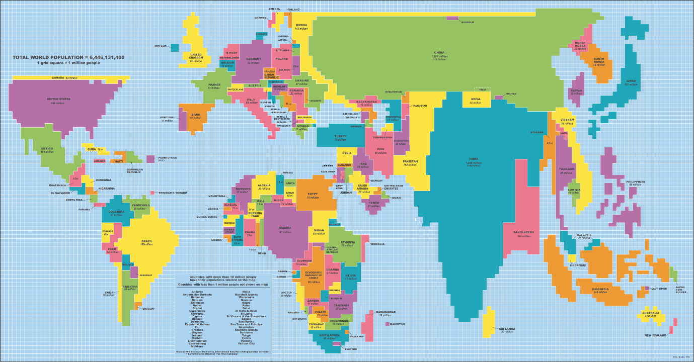

<http://www.iflscience.com/environment/world-map-scaled-population-size/>

The above map is a representation of the world. As the world is shaped like a globe it is impossible to recreate the exact geometric size and positions of each landmass, country and body of water with complete accuracy. Often countries around the equator are made smaller in comparison with areas near the poles. (Use the diagram below as a reference) Countries in central Africa are made appear very small while Canada, Greenland and Australia appear much larger in comparison. The above world map doesn’t use land area or any sort of geometric measurements to produce the shape of the countries being shown. It uses the layout of a world map as a reference point for where each country is located but the shape and size is determined by the population of each country. This is particularly interesting in demonstrating the population density of the world and in many ways the significance of that area with the world. For example, the populations of India and China are over 1.3 Billion people each. While the population of the world is 7.6 Billion people. Roughly a 3rd of the worlds population live in these 2 countries and it can be seen very clearly in this map. A standard map of the world which is stretched near the poles can add a lot of weight to countries which contain almost none of the worlds population and in many ways this can effect the perceptual significance we have for these countries.

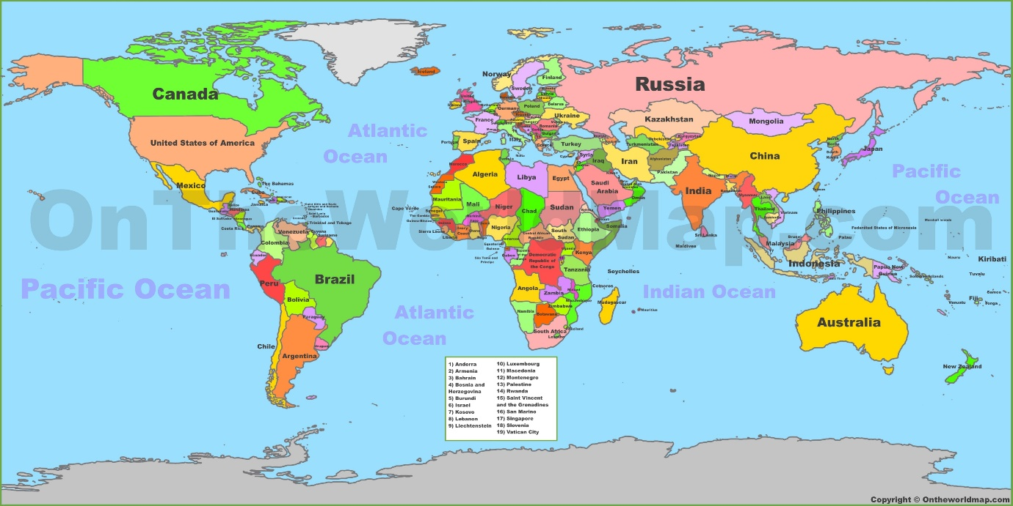

<http://ontheworldmap.com/>

A dataset that I believe could have great application if visualised correctly is energy consumption by a country and the way in which that energy is produced. Like the example above, if this data were to be represented in a way that it effects the size of the country which it represents then this could allow scientists and climatologists to easily identify areas of the world that are causing the most damage so the environment.

Instead of building the map based on raw energy consumption alone, it could also be colour coded from green to red where green is energy completely produced by renewable sources and completely red being unrenewable and environmentally harmful sources. In this way large areas that are bright green represent countries who use a lot of energy but do so in a sustainable way; large red areas on the contrary would be a major cause for concern.

It would also probably be ideal to correctly identify what the largest users of power are in each country and collectively around the globe. By creating colour coded bar charts, we could possibly interact with the visualised model by selecting individual countries or continents or the entire globe and see where energy is being consumed the most. The map could also be colour coded for different schemas like the activities which have the largest power consumption in each country.

The data about energy consumption could also be tracked over time and graphs could be drawn up to demonstrate trends in power consumption around the globe over the period of weeks, months, years, decades, even centuries if the data can be recorded for that long. In doing so it would help identify countries which are not using lots of renewable sources at the moment but have shown a trend of improving their energy efficiency.